Family Learning Group
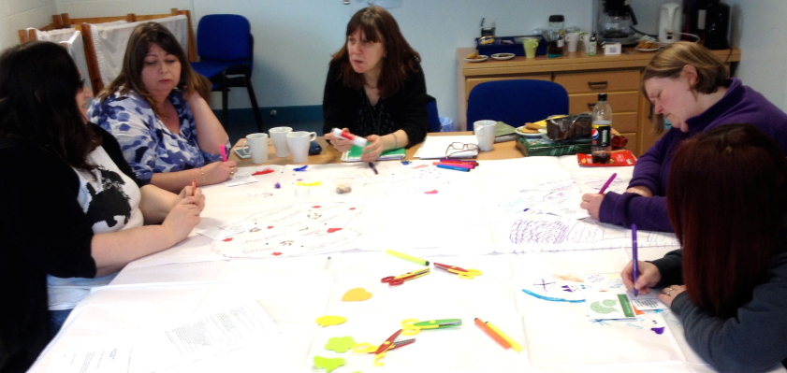
The group
The Broomhouse Family Learning Group is an ongoing group of parents whose children attend Broomhouse nursery and primary (it’s open to all, but tends to be parents of early years children). The group meets every Wednesday from 9 – 11. The main focus of the group has been looking at early literacy/numeracy and ways to support their child with learning. It is mainly a support group and the children are looked after in a crèche. The group has covered topics such as parenting (Raising Children with Confidence), play, healthy eating (working with a dietician) and projects with other agencies (National Museums of Scotland, Magic Carpet – a storytelling resource).
There were 6 participants and one worker participating in the session.
Aim of the session
Explore new approaches to gathering learners’ views of their personal learning experiences. Try out some methodologies and consult with the learners on how useful they felt the methodology was. Identify learners’ experiences of consultation in the past and find out what their ideas are on the best way to share their views and input into the planning process.
Method
Prior to the session, contact was made with Mhairi (CLD worker) to find out about the group and to discuss possible methodologies. Once the methods had been agreed, an information sheet was sent to the group to give them some background, context and outline of the planned session.
Methods used:
Introduction
Started with an introduction about the purpose and content of the session and informed them about the feedback they would receive.
Quick fire questions
To get the learners engaged with the topic, a round of quick fire questions was posed to help focus on the issues.
The questions were:
- What does Family learning and this group mean to you?
- What do you call the group?
Round the table discussion, café style
Utilising some of the methodologies inspired by world Café adapted to suit the context, particularly writing on the tablecloth. Prior to the start of the group the table was covered with paper tablecloths, with newspaper underneath to prevent pen marks transferring on the table below. The group were encouraged to write/draw/doodle/create or use words or pictures to illustrate their thoughts. A selection of colourful fruit smelling pens, newspaper/creative-crafting accessories, glue stick and craft scissors wee provided for the group.
Hospitality – biscuits and fruit were available with tea and coffee to set a relaxed café atmosphere for discussion
Round table semi structured discussion
Posed a number of questions to the group and facilitated discussion, which was recorded using a smart pen.
A camera was used to take photographs of the group and photo permission slips were used to ensure that they could be used in the final publication.
The questions asked were:
- Have you been asked your views on your learning in the past?
  - If yes, how was this done? Did you get any feedback?
  - If no, would you like to have been asked your views?
- What comes to mind when you think of your learning?
- How much say do you have in planning the group?
- What is the best way to have your say for you and your family e.g. on what is available and how it can be improved?
- What can be done to improve access to learning in Edinburgh (what prevents people getting involved)?
- What do you think about the way you were consulted today? (this activity)
Answers on the postcard Magic wand question - If you could wave a magic wand tomorrow, what would you wish be for adult learning?
Each person in the group was given a postcard with a visioning question on it and asked to complete it. This provided an opportunity to think without limitations, about their vision for adult learning. If there were no answers, what would their wish be for adult learning?
Resources
- Flip charts or paper tablecloths
- Fruit smelling pens
- Biscuits/fruit
- Livescribe Echo smart pen
- Camera
Timings
The group took part in the activity for the duration of the session, which was two hours.
The Results
A number of methodologies were used with this group to try to engage them in discussion, capture their experience of consultation and their ideas about how best this could be done in the future. The group engaged well with the discussion and utilised the writing on the tablecloths effectively. The postcards were effective with a 100% return
What impact might this activity have on the organisation involved?
Planners may wish to consider some of the learners’ feedback when organising provision in the future. This session identified some of the things that worked well in the provision that was visited and may provide some useful points to consider when planning for the future
What impact might this have on local or national planning for adult learning?
They may wish to pick up the concern about the general lack of crèches for adult learning and how much it is crucial to enable participation in this type of group.
How are expectations generated through engagement managed after meeting the group?
Prior to the session the group were informed about what was planned and at the start of the session they were consulted about whether they were content to take part. One theme that came from the discussions with the group was the importance of feedback to the learners. Although they had taken part in a number of consultations, in a variety of different contexts, it was rare for the learners to receive feedback after the consultation was complete or information on any actions that were taken as a result of the consultation. However, the learners recognise that the book group has a positive culture of listening to learners and negotiation about the work that they do! The learners were informed that the group would be sent a copy of the information gathered from the visit, prior to completion of the final report on New Approaches to Gathering Learners Views.
Reflection on /evaluation of method
The family learning group was a well established long running group, who were comfortable with discussion, so this made the café style discussion particularly suitable. However to get the group focussed on a different type of discussion, rather than general chat, the free word association provided a clear shift of focus, which was useful. This learners value this group as a support group and chat is an important part of the process. In using this method, it was also important to leave some space for this to happen and not to become too task focussed. The group had a useful and interesting discussion about an issue that was not related to the consultation, but useful to the group, so it was decided to make space to allow this to continue. Time at the beginning of the session was important for catch up with each other before settling down to the task. It was also important to provide information about what the session was for and the group were supportive and participated fully. The smart pen was once again a useful way of capturing the discussion for writing up later and it allowed the discussion to flow without having to stop to ensure written notes were captured fully. However, if this was not available other methods could be used. The creative accessories were used to varying levels, but writing on the tablecloths added an additional layer of information, which was useful. As with previous groups here was a good response to the postcard with the aspirational, wide open question.
What the learners said about their learning:

The postcard responses have now been represented as a Word Cloud, giving a visual representation of all four groups’ views.
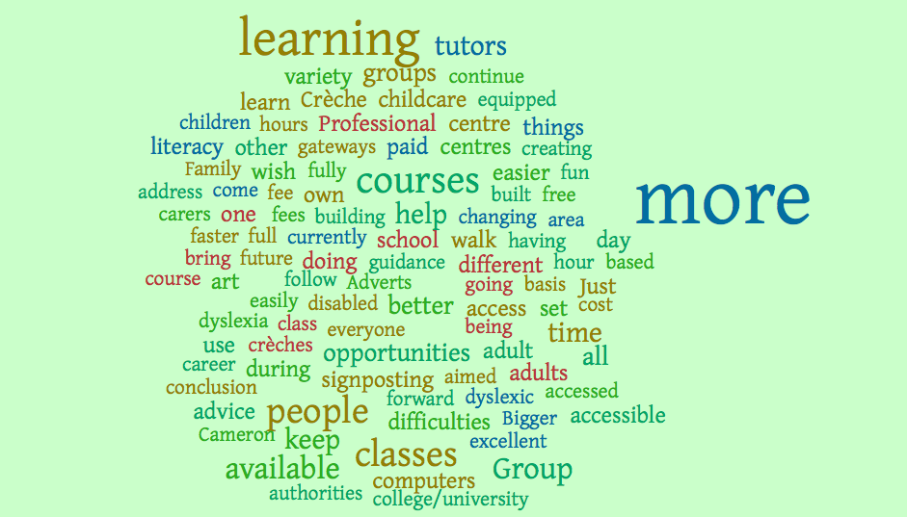

The Word Cloud features words from the responses to the on the postcard. The words repeated most appear larger.
What do you call the group?
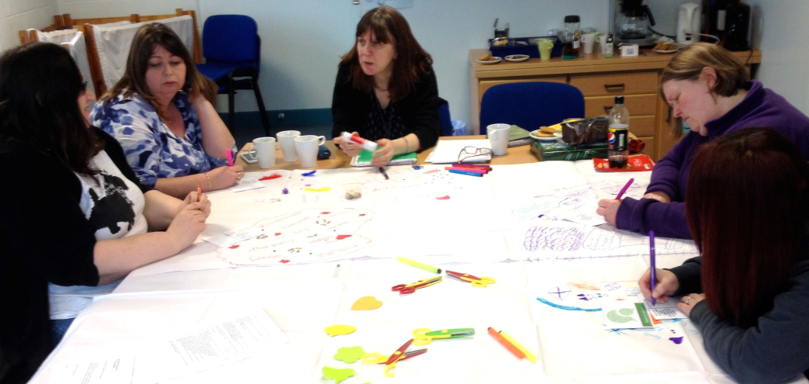

Family Learning Group - not official name!
Tell me about the group
Rolling group can attend as long as they want. Some people have been there a long time and one attends now with grandchildren.
What does family learning mean to you?
We do a lot of activities:
The carpet project for the Museum Scotland put our own ideas and got the kids in to help with it "we did some nice stuff. They won an award for it and now it travels round schools and nurseries 3 groups involved, very creative.
Growing in Confidence, she teaches us and we take it home and it effects our family, I suppose that is what you would call family learning.
Do a lot of healthy eating themed work and a lot of cooking with dietician, Eat Feel better government campaign. We have done a few other courses as well
They asked us to do case studies and one of the groups case studies will be featured in the evening news
We find out about other courses to further our education. I found out about crèche work and that is how I got working in that.
We do Book Bug and chat let off steam!
Free word association – what is the first word that comes to mind when you hear this word?
Family – nippiness, lack of sleep
Learning – computer, kids, activity, books,
Play – messy, fun, wrong shoes on the wrong Barbie, role-play
Education – problems, school, courses
Future – unknown, hopeful
Children – stress, love, stressful
This group – relaxing, de-stressing, support, sounding board, a bit of sanity, release, us time, talk to other adults, informative
How do you decide what you are going to do from week to week?
We come up with ideas and Mhairi makes it happen like the cookbook, magic carpet museum asked for people to get involved they got a night out at the end.
How long has the group been going?
5 or 6 years runs all the time term time – hate when the holidays are coming up and the group gets cancelled.
We sharing information on best buys, deals etc.
Have you been asked your views?
We were asked at City Chambers?
Enjoy healthy eating sessions
bring ideas to group and ask if it is possible to do it or worker brings ideas and asks the group.
This is a relaxed group
Crèche is very important wouldn’t be able to do half the stuff if the children were in the group need the peace just one or two can be in the group if they are not settling in the crèche. Kids have grown up together and have become friends. Attend a number of other things in the school together, mums and toddlers and help out with things in the school and at the nursery at Christmas.
What would be the best way to find out what parents want?
We usually talk about it in the playground and if there is someone new we tell them about it and ask if they want to come along. The nursery also tells them about the group and encourages them to come along
Better to hear from other parents
Concerns don’t feed back to the school although there is a feeling that they could go to the school if there is a problem.
Can’t get involved or nominated for parent council if you are a grandparent, you have to be a parent.

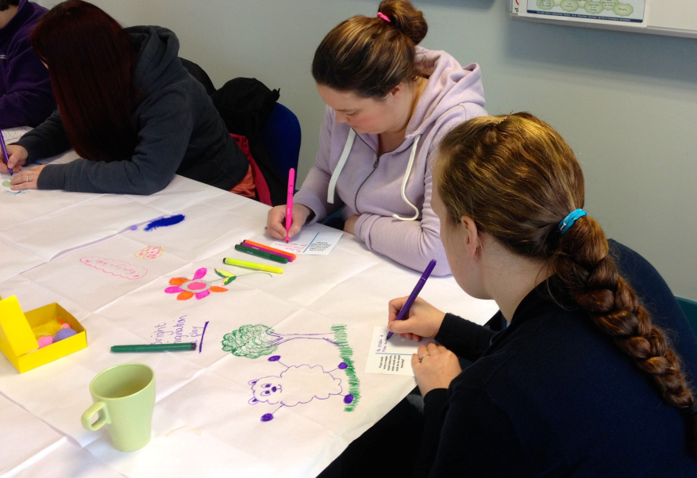
What is the best way to have your say?
Just ask in person. We have had questionnaires in the past when the inspection was taking place. Did complete it came with an envelope. Never got any feedback from the questionnaire, it’s whether they paid any attention to it. They only got the final inspection report. If it is done by individual questionnaires, without feedback, you don’t know what other people are thinking or saying, you think that you are the only one who thinks like that.
Questionnaires are good but it is important that you get feedback, it would be good to let you know what the result of your input is.

What can be done to improve access to learning in Edinburgh?
Childcare is important to be able to take part need more.
Would questionnaires have been better?
We would maybe not have answered it properly we may have answered it quick. When we are talking if somebody says something it makes you think and you have a better discussion.
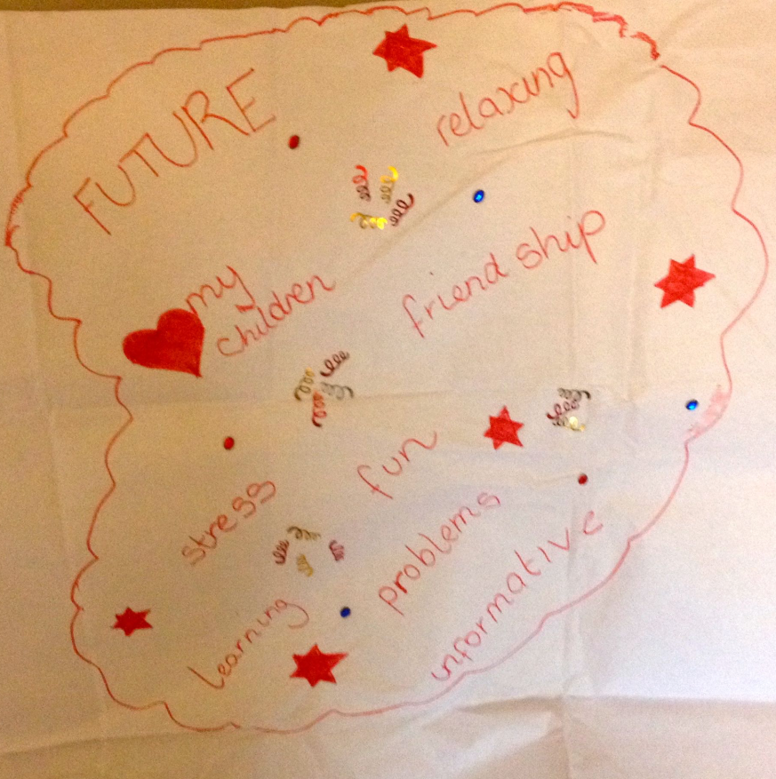
What did you think of today?
I liked the drawing and doodling because this was the first time we had done it if we were to do it again we would probably get more adventurous, help each other, we have used magazine good if somebody doesn’t speak a lot of English, it can help using magazines and drawing to get them to know what they are doing also if you are not comfortable with their writing. Photographs are also good rather than asking them to write photograph provide evidence.
This is a good support group.

What do you think about the way we have been doing consultation today?
Felt very relaxed, don’t feel pressured into it you don’t realize that you are answering question
Wondered what we were up to when saw the pens etc. used to doing creative stuff
Would questionnaires have been better?
We would maybe not have answered it properly we may have answered it quick. When we are talking if somebody says something it makes you think and you have a better discussion.
Would social media be useful for getting feedback about learning?
Facebook might be useful to hear about new courses and you can read what other people are thinking about it would be useful.
Reflection on evaluation method
The family learning group was a well established long running group, who were comfortable with discussion, so this made the café style discussion particularly suitable. However to get the group focused on a different type of discussion, rather than general chat, the free word association provided a clear shift of focus, which was useful. This learners value this group as a support group and chat is an important part of the process. In using this method, it was also important to leave some space for this to happen and not to become too task led. The group had a useful and interesting discussion about an issue that was not related to the consultation, but useful to the group, so it was decided to make space to allow this to continue. Time at the beginning of the session was important for catch up with each other before settling down to the task. It was also important to provide information about what the session was for and the group was supportive and participated fully. The smart pen was once again a useful way of capturing the discussion for writing up later and it allowed the discussion to flow without having to stop to ensure written notes were captured fully. However, if this was not available other methods could be used. The creative accessories were used to varying levels, but writing on the tablecloths added an additional layer of information, which was useful. As with previous groups here was a good response to the postcard with the aspirational, wide open question.

