 

**New Approaches to**

**Gathering Learners’ Views**

**The Learners’ Views**



Image courtesy of [www.comraich.me](http://www.comraich.me)

**Background**

In the **Adult Learning in Scotland Statement of Ambition**, one of the key success factors is that it is important that policy development always involves adult learners and that learners’ views are taken into account in their personal learning, in local planning areas and at national level.

Funded by CLD Innovations and Improvement, Learning Link Scotland and the Workers’ Educational Association (WEA) have conducted a series of consultations into methods of gathering learners’ views.

The project involved adult learning groups from the WEA, Edinburgh City Council and Edinburgh College.

The main themes to emerge were around security of provision, consistency of location and the name of the group, funding, childcare and communication systems between the organisation and the learners in relation to changes in the service.

The following is a summary of the learners’ views gathered during the project.

The learners were from the following groups:

**Edinburgh City Council**

* Numeracy Group
* Broomhouse Family Learning Group
* The Book Talk Literacy Group
* Adult Education Jewelry and Stained Glass Group, part of the Open Programme

**Edinburgh College**

* Community based IT Group at Mussleburgh Community Learning Centre
* Two community based ECDL groups taking part in a joint consultation
* Edinburgh College Students’ Association Focus Group
* Edinburgh College Students’ Association Facebook Group

**WEA**

* WEA Lothian Local Association Group
* Scottish Literature Group
* Health and Social Care Group
* Communications for Social Care Workers Group

**The Learners’ Views**

**Edinburgh City Council**

**What the learners said about their learning:**

All learners who took part in the Edinburgh City Council consultation were asked ‘If you could wave a magic wand tomorrow, what would your wish be for adult learning?’ The words that are repeated most often appear larger in the Word Cloud.

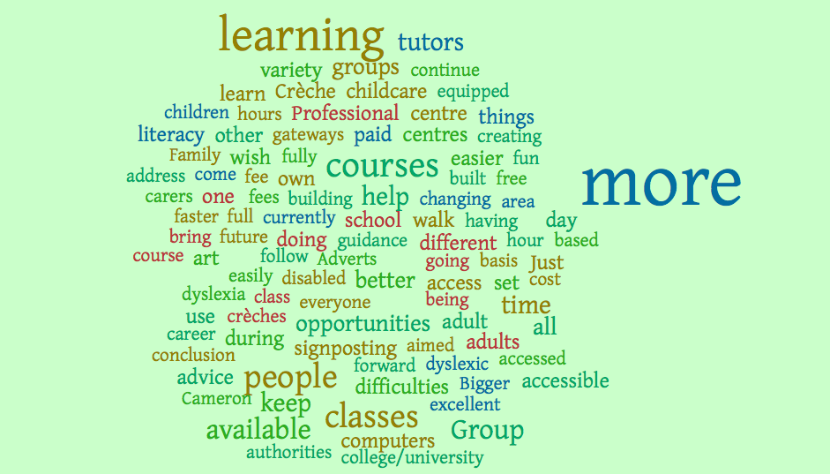

**Numeracy Group**

**The group**

A tutor and two volunteer tutors support the learners in the group. The learners use individual learning plans to identify their own priorities and interests around numeracy.

**The key views of the learners were that:**

* It is important for our views to be heard, because we are the ones who are experiencing the learning and know most about it. We have insight into how to improve things**.**
* We feel confident as a result of our numeracy class and we know that it is okay to make mistakes and that we are not alone.
* We appreciate the small group setting for learning and that we are allowed time and space to make the most of learning.
* We would like to talk and write to people who make the decisions about budgets, asking questions and asking for justifications for cuts in funding.
* We could attend organised events and focus groups and speak up.
* Group discussion is a good way for us to get our views across, with the facilitator recording the answers.
* It’s important for us to get feedback after the consultation to find out about the impact of our involvement.

**Family Learning Group**

**The group**

The Broomhouse Family Learning Group is an ongoing group of parents whose children attend Broomhouse nursery and primary. The main focus of the group has been looking at early literacy/numeracy and ways to support their child with learning.

**The key views of the learners were that:**

* There is a lack of crèche support for adult learning.
* Crèche facilities are crucial to enable us to take part this type of group.
* Family learning means that we can learn about things that will help us and our children like healthy eating with a nutritionist. It also means we can take part in learning opportunities leading to employment, share information about finance and the group also provides an opportunity for support and letting off steam.
* The best way for us to have our say on learning is to ask us in person, rather than by forms or questionnaires. We would like to get feedback on the result of the consultation and would like to know that our views are being listened too.
* Childcare is the biggest concern for this group, in order to take part.

**Book Talk Literacy Group**

**The group**

The Book Talk Group is principally a literacy group. Individuals work mainly on a one-to-one, with occasional group work. Two volunteer tutors support the paid tutor.

**The key views of the learners were that:**

* We are worried about the uncertainty of funding for classes.
* We need to be told about budget cuts and the implications these cuts have on our classes.
* We have been consulted in the past, but have had had no feedback from that consultation which was mainly carried out by questionnaire.
* We liked the discussion and think it might be useful to do a group exercise, discussing our learning, before we complete any forms, this will help us to get our thoughts together.
* We could do a group activity at the end of each term, so we can have an opportunity to talk and think about our learning and plan for the following term.
* We are very involved in deciding what we do and what we want to do.
* We are frustrated about the changes in the name of the service, and feel that it is confusing and may put people off because they are not sure what it is. So it should be kept the same

**Silver Jewellery and Stained Glass**

**The group**

The group consisted of two groups from the Edinburgh City Council Adult Education Programme taking part in a ten-week programme - Silver Jewellery Making and Stained Glass (intermediate). These are two separate groups meeting in the same large room at the same time, each with their own tutor. The group is made up mainly of retired adults and many of the participants were continuing from previous sessions moving from introductory to intermediate skill level, although there were some new participants. Learners mainly worked on their own projects supported by the tutor on a one-to-one basis. The group also appeared to support each other in their projects and share ideas and expertise.

**The key views of the learners were that:**

* Learning a new skill and enjoying learning are very important but the social side to learning also featured strongly in responses.
* One lifelong learner was keen to impress that it is never too late to learn, as at the age of 78 she is still learning new things.
* As both of these groups were creative groups, they enjoyed making things for themselves and valued having protected time to do that.
* Better venues would be something that would help access. The group had fairly recently been moved to the current premises, which is not as suitable as the one they were in previously.
* Not everyone has access to the Internet, so it is important to have information about learning available in a variety of formats.
* There was a view that, for consultation with learners, Survey Monkey had limited reach.
* It was felt that barriers include availability of crèches and cost. These factors may prevent potential learners getting involved.

**Edinburgh College**

**Community Based IT Group**

**The group**

This was a College Community based IT group running in a Community Learning Centre, the group consists of 6 to 12 adult learners, all female, whose ages range from mid twenties to late sixties. Several learners in the group have attended for more than two years, although there are new learners joining all the time.

**The key views of the learners were that:**

* The learners came to the group because of reasons that included becoming unemployed after ill health; early retirement; losing a job; confusion about where to start with IT and being given computer.
* Barriers to learning had previously included: my memory lets me down sometimes due to Parkinson’s; it can be an uphill struggle getting into the course with wheelchair; finding the correct course with disabled access; lack of confidence, health issues, family issues, transport difficulties and instability in how the class ran, changes in tutors and classes /venue were all unsettling, the learners had to start at a new venue and some people stopped and didn’t come back.
* Barriers were overcome by perseverance and because the computer course gives learners something to do.
* People who have helped include: the other learners, the tutor, friends and the janitor
* The things that have helped learning are excellent premises; that the group gelled well; coffee break chat; learners build up friendships; the tutor is great and that learners enjoy the class and want to learn more, it opens everyone’s eyes with what’s going on in the world.

**Two community based ECDL groups** **using Survey Monkey**

**The group**

Two community based European Computer Driving Licence groups expressed an interest in completing an online survey to share their views on giving feedback when their tutor asked if they would like to take part in the project and try out an online method. However, only one individual filled in the survey despite an extension to the deadline and repeated reminders to fill it in.

**The key views of the learner were that:**

* Learning providers should listen to learners’ views because it should help the providers understand the needs of the learners.
* If I could wave a magic wand tomorrow, I would wish for more outreach courses, non-computing. Adult learning is also about getting people out socially to develop social skills.

**Focus Group**

**The group**

A face to face focus group made up of students from the Granton campus of Edinburgh College. Despite invitations being sent to a large number of students via the Students’ Association along with the offer of a £10 Amazon voucher for attendance, only 3 students came along to the session. Participants explained that students are constantly being asked to attend one focus group or another so it can be very difficult to persuade people to come along when they’re already so busy.

**The students’ recipes for success are illustrated as follows:**

Recipe for a successful learning programme



**Ingredients:**

* 500g of … funding
* 250 ml of … quality education and leacturers
* a pinch of … extra support
* 2 cloves of ... student community

**Method:**

1. Mash em up in a pot. If the ingredients are nice the food will (hopefully) be too.

2. Use the quality education and lecturers as the main ingredients, combined with support and student community.

3. Use funding liberally spread over to richen the flavour!

Recipe for a successful learning programme



**Ingredients:**

* 500g of … structure
* 250 ml of … goals
* a pinch of … passion
* 2 cloves of ... imagination
* … a twist of creativity

**Method:**

1. Take your goals

2. Formulate your structure

3. Simmer in your imagination

4. Stir with passion.

5. Add a twist of creativity

Recipe for a successful learning programme



**Ingredients:**

* 500g of … high quality learning and teaching
* 250 ml of … information, advice, guidance and support
* a pinch of … student led
* 2 cloves of ... reflective practice
* … funding and support

**Method:**

1. Structured planning and delivery

2. Clear, accessible information

3. Framework which puts students in the driving seat

4. Meetings, quality processes, surveys

5. Accessible funding that meets students’ needs, accessible application process.

**The key views of the learners were that:**

* If we could wave a magic wand and change things for adult learning, then we would wish for better financial support and good communication
* Our class has come up with a list of everything that helps with the course … it’s been great. Lecturers and tutors need to be reflective though. An anxious lecturer makes for an anxious class!
* People like to be taught in different ways. If you want to learn in a different way you have to do it in your own time and work out how … it’s mainly taught as a group in the same way to everyone.
* In one of my classes I suggested more interactive activities and that worked well. I think it’s important that lecturers ask people how they learn best.
* Some styles of teaching are great, some are not so good. It’s not just about teaching methods, a lot of it’s down to communication. It has to be flexible … change the font, make wider spacing, talk more, use media … these small things can make a huge impact.
* I’ve suffered a head injury in the past and it can take me longer to process information. Sets of instructions don’t always work for me. Learning styles are really important, so’s knowing the student profile.
* It takes quite a brave person to speak out and say what we need. A quiet or socially anxious person is much less likely to speak out.
* The college needs to think about the support provided at the application and selection stages. With the right processes in place the necessary support can be made available.
* I’m a class rep and I take anonymous messages and feed them back on behalf of the whole class. Class reps need to make sure to feed back the positives as well as complaints. It also works better if they provide potential solutions and not just a list of problems. There aren’t class reps for every course unfortunately.
* There should be more interfaculty interaction and communication. It does happen but perhaps just in pockets. Where it does happen it’s really good and should be celebrated more. It would be better if it was organised more formally though. At the moment it relies on students from different courses seeking each other out.
* The good thing about being a mature student is that you’re more self assured and less scared to speak out for yourself. The transition from school to college is difficult for a lot of the younger students – they can be quite surprised that it’s much less formal and that they need to take more responsibility for themselves.
* I think the most important thing for mature students is access to funding at all levels.
* It’s also important that people realise that not everyone at college is young!
* If college wasn’t here I’d be in a dead end job because my qualifications from Greece don’t translate to anything of real value here.
* I’m interested in the Nordic model where vocational strands of education are valued just as much as higher education.

**Facebook Group**

**The group**

A focus group made up of 11 students from a range of courses, including HNC Social Sciences, NC Business, NC Health & Social Care and NC Exercise & Fitness. The group ran for a period of 14 days. For the first 7 days the facilitator added a question each day. For the second 7 days the page was left open for anyone who hadn’t had a chance to participate yet to join in.

**The key views of the learners were that:**

If we could wave a magic wand tomorrow, our wish for adult learning would be:

* An obvious and constant wish.....more financial support, especially childcare!
* To be instantaneous - take about 2 seconds to upload all knowledge, social experience and anything of value into the malleable minds of students. But REALISTICALLY speaking I'd also wish for more financial support, especially childcare!
* An education system that is open, accessible and funded to an appropriate level, for all ages. That was cheeky!! My more achievable and realistic wish would be a structured nationally funded and endorsed FE/HE articulation agreement into employment and Higher Education that was strengthened by legislation that placed a much greater emphasis upon the various sectors and Universities to start building a better and more sustainable destination for students.
* Better financial support, childcare is a must and increased knowledge and understanding of all processes and course content so future students have in depth knowledge of what they are about to undertake without having to resort to finding things out while going through the paces in the course itself.
* Communication of all sorts. Information about your own course and progression routes as well as information about events, societies and support available.

**Workers’ Educational Association**

**WEA Lothian Local Association**

**The group**

WEA Lothian Local Association. Student representatives from Theatre Studies, Diggers Writers’ Group, Book Talk, Exploring Books, Breaking the Mould Women’s History project and Lothian Women’s Forum.

**The key views of the learner were that:**

Learners stated the importance of their learning and group activities for health and well-being. This was expressed in terms of: keeping their minds active; getting them out of the house and combatting depression; meeting new people; and getting some brief respite from caring responsibilities. They were also devoted to being part of an organisation with a social purpose and are committed to the WEA prioritising work that tackles poverty and inequality whilst enabling their groups to continue as self - organising student groups.

**Scottish Literature class**

**The group**

Workers’ Educational Association Scottish Literature class.

**The key views of the learner were about:**

* **Getting Involved**

There was a mixture of responses from those wanting an opportunity to learn about Scottish culture and literature for the first time to people wanting to further their interest in Scottish literature.

* **Participation**

Participants are encouraged to read out extracts from the literature, often in the Scots’ tongue, which is a challenge for some of the learners but one they relish and enjoy.

* **Influencing**

The group co-produces the curriculum with the tutor for the next session of learning and they will be discussing ideas for authors and themes next week.

The group members are thinking about the group becoming a constituted student group.

* **Impact**

The learners benefit greatly from the social aspect of the course enjoying meeting a range of new people who all learn from each other. For most the class is one of the highlights of their week and is very good for breaking down the social isolation of retirement and a home based interest in Scottish literature.

* **Progression**

Many of the group members attend other WEA classes, University of Edinburgh and City of Edinburgh Council adult learning classes.

* **Involving You**

It would be better if City of Edinburgh Council, University of Edinburgh and WEA had greater consistency in their fee structure and information on adult learning across the City.

Keep us informed about any changes and new courses

* **Barriers**

Accessibility of venues for those with mobility problems

Quiet venues with low background noise for the hard of hearing

Prefer three short terms to one or two longer terms mainly because of the worry of paying up front costs and committing to 16 or 24 weeks rather eight weeks at a time.

**Employability Fund Stage 4 Health and Social Care**

**The group**

Workers’ Educational Association Employability Fund Stage 4 Health and Social Care

**The key views of the learner were that:**

The Community Learning and Development Plans 2015/2018 could have a social media link so the learners and citizens could give the views on the adequacy and efficiency of the plans in their development stage, and then at least once in years: 2015/2016, 2016/2017 and 2017/2018.

**Core Skills for Social Care Workers**

**The group**

WEA SQA Core Skills Communication Access 3/Intermediate 1 for Social Care Workers.

**The key views of the learners represented in a word picture:**

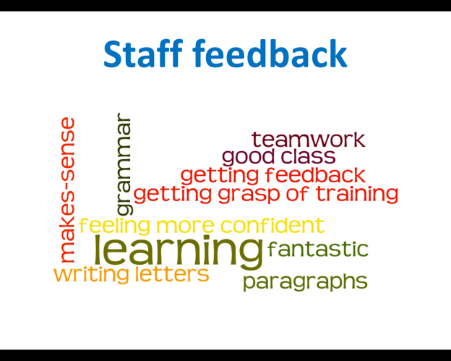

Report Prepared by

Jackie Howie

Lead Officer

Learning Link Scotland

17 Gayfield Square

Edinburgh EH3 1NX