

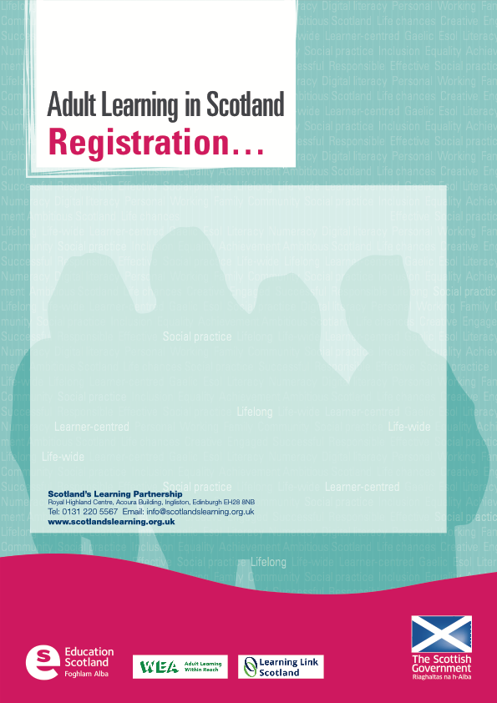

|  |  |
| --- | --- |
|  | **X** |
| **Dundee, Wednesday 6th June, 2pm-4.30pm** (please reply by 1st June) |  |
| **Glasgow, Monday 11th June, 2pm-4.30pm** (please reply by 7th June) |  |
| **Edinburgh, Thursday 14th June, 2pm-4.30pm** (please reply by 11st June) |  |

|  |  |
| --- | --- |
| Name: |  |
| Organisation: |  |
| Address: |  |
| Town: |  |
| Postcode: |  |
| Telephone: |  |
| Mobile: |  |
| Email: |  |
| Special requirements: |  |

|  |  |  |
| --- | --- | --- |
| Please keep me up to date |  | Email registration to: [lee.callaghan@scotlandslearning.org.uk](mailto:lee.callaghan@scotlandslearning.org.uk?subject=Strategy%20consultations) |

**I am able to attend the consultation on the Development Strategy for Adult Learning on:**